Forklift Safety Refresher | Safety Training Handout
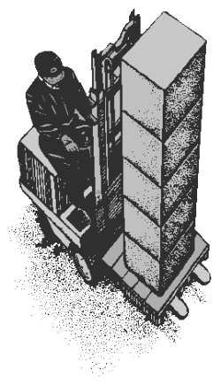  Forklift operators must know & follow equipment operating procedures and safety rules for forklift operation. Specifically the hazards involved in:  - Equipment operation  - Traffic paths & surfaces  - Operation around pedestrians  - Loading & unloading characteristics  - Height & travel clearance  - Forklift ratings  Daily Checklist… before you go check  Controls Leaks Horn Lights Alarm Battery Steering Brakes Missing Parts Extinguisher Seat Belt Fuel  Park Safely!  - Lower the forks & set the brake  - Turn off motor & remove the key  - Always park on a level surface  - Don't block emergency exits or equipment  - Park away from other hazards |  | Dock Safety…  - Inspect the truck floor  - Check trailer chocked  - Inspect dock plates  - Check for liquid spills  - Watch other traffic  - Get permission  - Check dock-locks  - Check warning lights  Hazard Awareness…  - Speed & clearance  - Fork position  - Load stability  - View of path, pedestrians & other traffic  - Drop-offs & ramps  - Surface hazards  Traveling Safety…  - Tilt the mast back before traveling  - Keep forks 4 to 6 inches off the floor  - Keep at least 10 feet overhead clearance between mast and overhead power lines  - Position the load against back rest  - On ramps have the load positioned up hill of the forklift  - Ensure adequate clearance  - Never overload forklift

